33. Animal Behavior: Social Behavior *(Chapter 56)*

______________________________________________________________________________

IV. Animal Societies *(1355-1356)*

A. Conditions Favoring Dispersion in a Population

B. Animal Societies

1. Definition

2. Communication as a requisite for social behavior

3. Nonsocial aggregations

C. Simple Societies

1. Parental care

2. Motion groups

D. Dominance Hierarchies

1. Leadership

2. Groups with fixed composition

3. Structures of hierarchies

4. Dominant animals

5. Appeasement by submissive animals

6. Sex reversal in some fishes

V. Sociobiology *(1357-1358)*

A. Goals and Methods

B. Altruism

1. Definition

2. Example

3. Apparent evolutionary paradox

# C. Kin Selection

1. Definition and action

2. Calculating degrees of relatedness

3. Prediction of animal behavior

VI. Complex Animal Societies *(1358-1359)*

A. Kin Selection and the Evolution of Complex Societies

B. Insect Societies

1. The queen and the castes

2. Organization and development of an ant colony

3. Communication within the colony

4. The importance of trophallaxis

5. Haplodiploidy and the evolution of sociality

C. Primate Societies

1. Diversity in social organization

2. Dominance hierarchies

3. Individual recognition

4. Use of ritualized behaviors

5. Potential for breeding

33-1

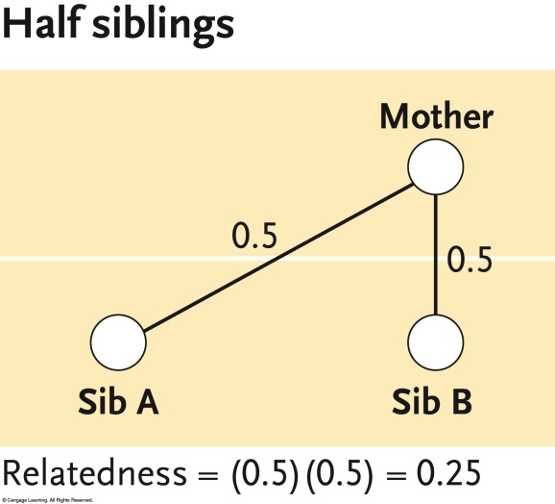

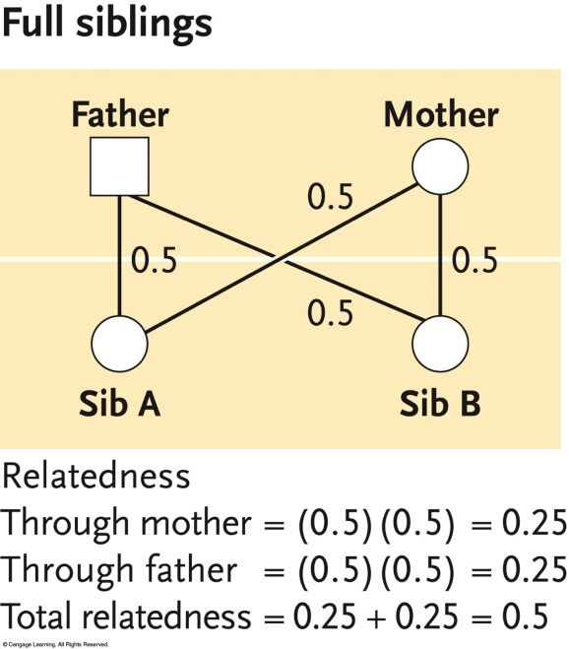

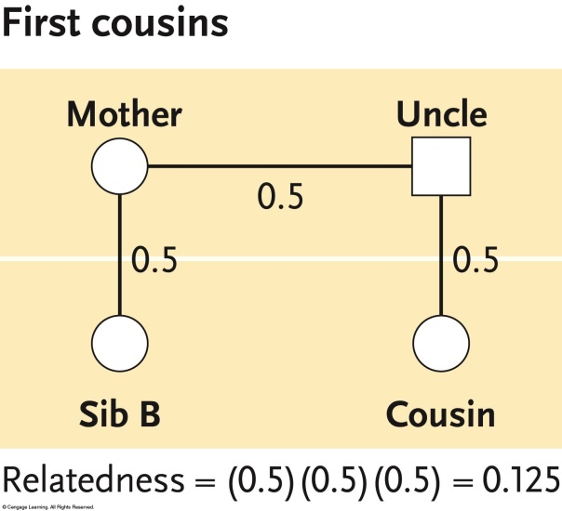

33-2

